|  |  |  |  |  |  |  |  |
| --- | --- | --- | --- | --- | --- | --- | --- |
| id | firstname | lastname | position_id | gender | salary | date_hired | Status |
| 1 | Jerwin | Cruz | 1 | M | 60000.00 | 2018-06-30 | ACTIVE |
| 2 | Peter | Parker | 2 | M | 65000.00 | 2011-12-02 | ACTIVE |
| 3 | Tony | Stark | 2 | M | 102000.00 | 2002-02-01 | ACTIVE |
| 4 | Natasha | Romanoff | 4 | F | 70000.00 | 2015-10-24 | ACTIVE |
| 5 | Wanda | Maximoff | 3 | F | 48000.00 | 2016-09-25 | ACTIVE |
| 6 | Steve | Rohers | 1 | M | 58000.00 | 2017-07-25 | ACTIVE |
| 7 | Stephen | Strange | 5 | M | 52000.00 | 2013-08-25 | ACTIVE |

1. Display all records if the employee’s gender is male and hired from 2013 to present.
2. Display firstname if the employee’s gender is male and second letter of lastname is letter

‘a’.

1. Display firstname if the employee’s gender is male and fourth letter of lastname is letter

‘a’.

1. Display the maximum salary.
2. Display the average salary.   
   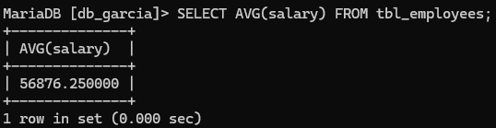
3. Display firstname if the employee’s gender is male and fourth letter of lastname is letter

‘p’.

1. Display the firstname of the employee if the salary is above 53000.
2. Display firstname of the top 3 employee with highest salary.   
   A screen shot of a computer

   AI-generated content may be incorrect.
3. Display firstname of the top 2 employee with lowest salary.
4. Display firstname of the top 2 male employee with lowest salary.